Platform Architecture and Interface Documentation

Architecture of Zoho Creators

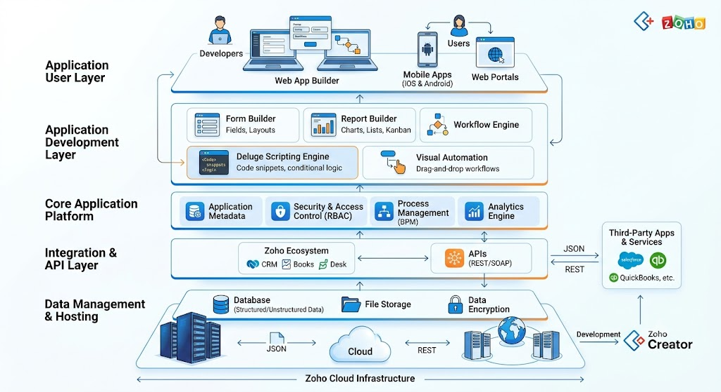

Introduction
This document provides a comprehensive overview of the Zoho Creator platform architecture and its user interface components. It explains the purpose, functionality, and practical applications of the major features available within the platform. The documentation is intended to help users understand how different modules work together to support low-code application development, workflow automation, data management, and business process optimization.
Each feature is described with its purpose, detailed functionality, key capabilities, business benefits, real-world use cases, and important notes. This structured approach enables developers, administrators, and business users to easily navigate and understand the platform's capabilities.

Feature Name: Applications
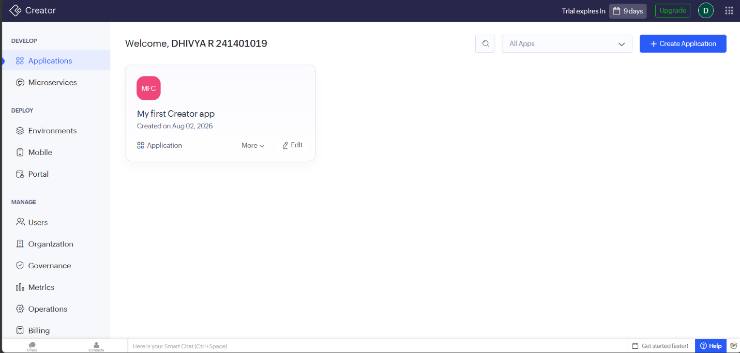

Purpose
The Applications module serves as the central workspace in Zoho Creator where users can create, access, manage, and organize all their low-code applications. It provides a single location for viewing existing applications and initiating the development of new ones.

Description
The Applications page in Zoho Creator serves as the primary landing page after users sign in, providing a centralized dashboard that displays all available applications as individual cards. Each card shows key details such as the application name, creation date, and quick actions like Open, Edit, and More Options, allowing users to easily access and manage their projects. The page also includes a Create Application option for building new applications from scratch or using templates, along with search and filter features that simplify navigation. By organizing multiple business applications in a single workspace, the Applications page streamlines application management, improves accessibility, and enhances overall productivity.

Feature Name: Microservices

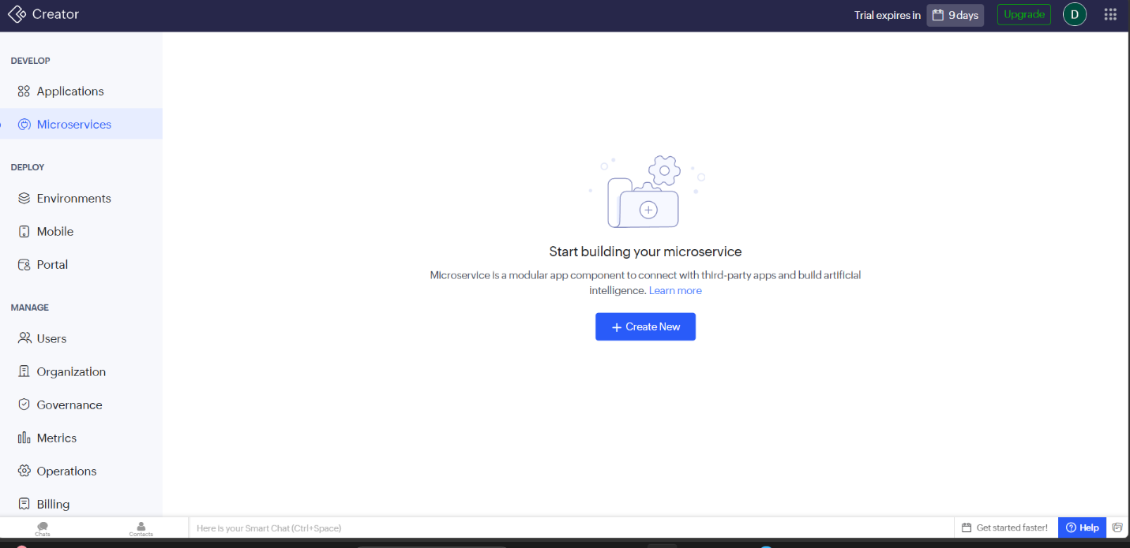

Purpose
The Microservices module in Zoho Creator enables users to build lightweight, modular services that can perform specific business functions independently. These services are primarily designed to integrate with third-party applications, expose APIs, and support intelligent automation without affecting the core application.
Description
The Microservices interface in Zoho Creator provides a dedicated environment for creating and managing independent service components that perform specific business functions. Unlike traditional applications, each microservice operates independently and can be reused across multiple applications or integrated with external systems through APIs. Users can create new microservices to execute custom business logic, process data, automate workflows, and support third-party integrations without affecting the main application. This modular architecture improves flexibility, scalability, maintainability, and reusability, making it easier to update, deploy, and manage individual services while ensuring seamless operation of modern business applications.

Feature Name: Environments
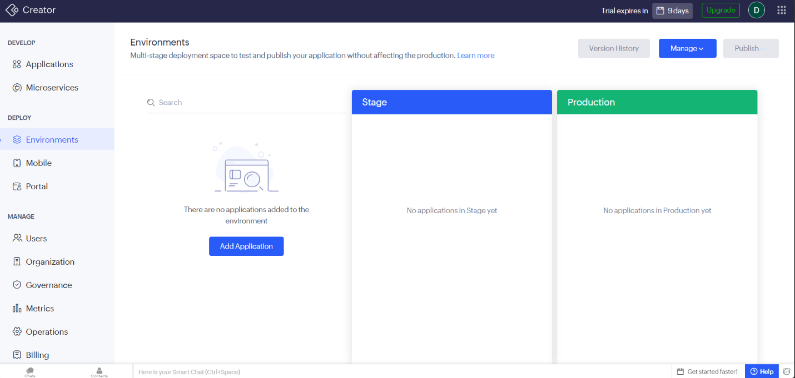

Purpose
The Environments module in Zoho Creator provides a multi-stage deployment framework that enables developers to test, validate, and publish applications without directly affecting the live production environment. It ensures safe application development by separating testing and production workflows.

Description

The Environments interface in Zoho Creator supports application lifecycle management by providing separate deployment stages, such as Stage and Production, to ensure safe and controlled application releases. Developers can deploy applications to the Stage environment to test new features, bug fixes, and updates before publishing them to the Production environment for end users. The interface also offers tools such as Add Application, Version History, Manage, and Publish to simplify deployment management, track application versions, and configure releases efficiently. By enabling structured testing and controlled deployments, the Environments interface reduces risks, improves application stability, and ensures reliable business operations.

Feature Name: Mobile

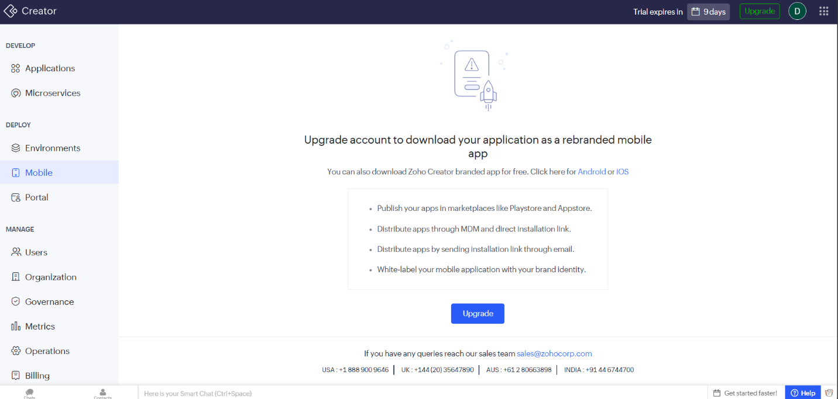

Purpose
The Mobile module enables users to convert their Zoho Creator applications into mobile applications, allowing them to access and use business applications on Android and iOS devices. It also provides options for branding, publishing, and distributing mobile applications.
Description
The Mobile section in Zoho Creator enables developers to make their applications accessible on mobile devices through the Zoho Creator mobile app or by publishing fully branded mobile applications with a paid subscription. It allows organizations to customize application branding, distribute apps through the Google Play Store, Apple App Store, Mobile Device Management (MDM) solutions, or direct installation links, ensuring secure and convenient mobile access for users. This feature enhances workforce productivity by providing anytime, anywhere access to business applications while supporting enterprise-level deployment and maintaining organizational brand identity.

Feature Name: Portal
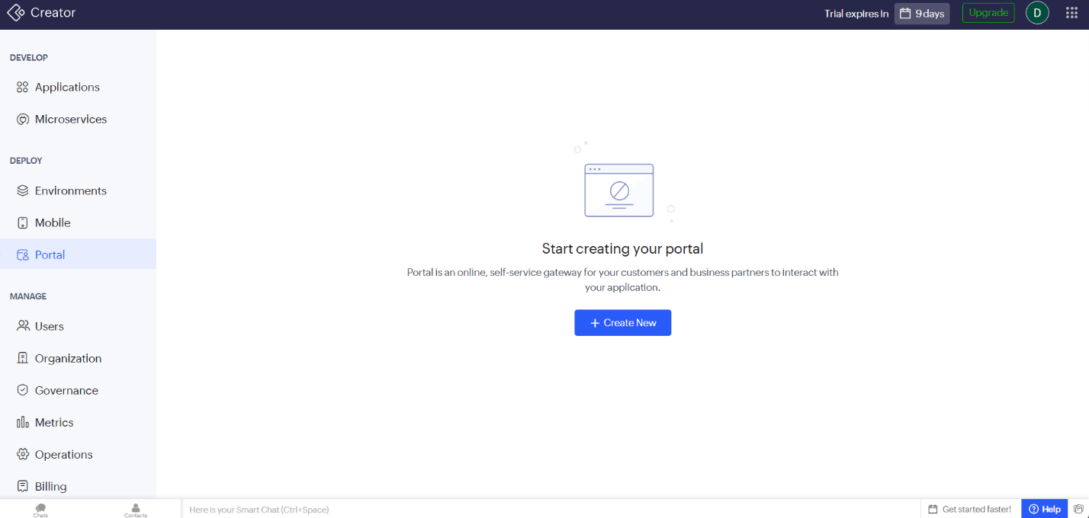

Purpose
The Portal module in Zoho Creator enables organizations to create a secure, self-service portal where customers, vendors, partners, or external users can access applications, submit information, and interact with business processes without requiring direct access to the Creator workspace.

Description
The Portal feature in Zoho Creator enables organizations to create secure online portals that allow external users, such as customers, partners, vendors, or students, to interact with applications through a dedicated interface. Administrators can configure role-based access permissions to ensure users can only view and access relevant features and data. The portal supports user authentication, personalized experiences, and self-service functionality, making it suitable for customer support, partner collaboration, employee self-service, and vendor management. By extending application access beyond internal users while maintaining security and data privacy, the Portal feature improves user engagement, streamlines business processes, and enhances overall operational efficiency.

Feature Name: Users

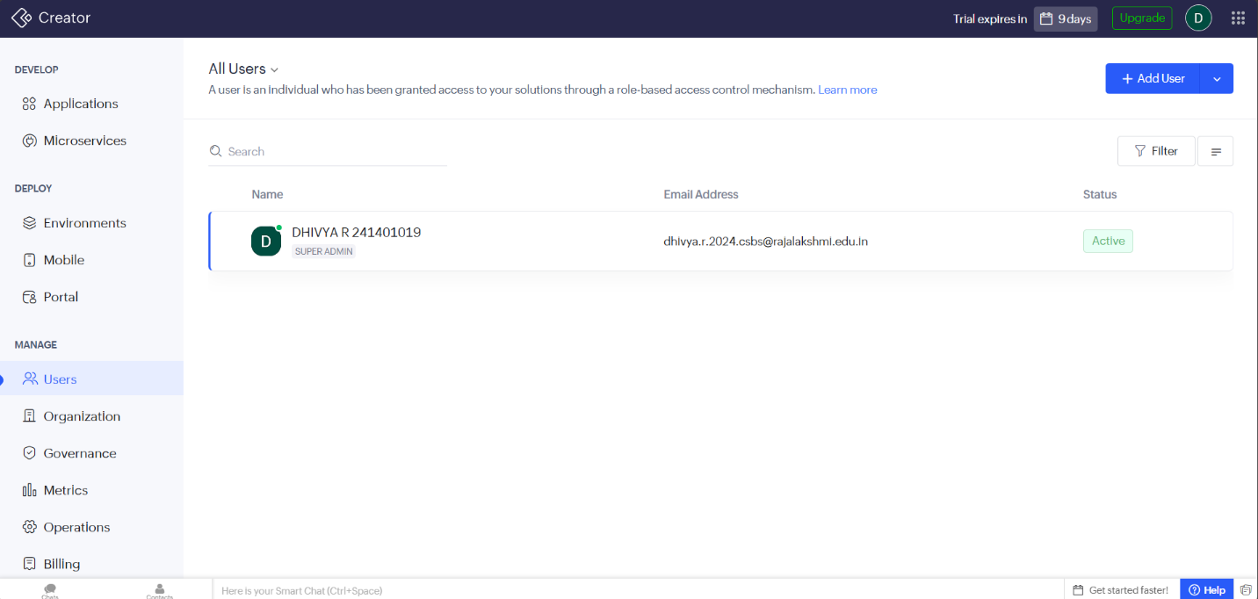

Purpose
The Users module in Zoho Creator is used to manage individuals who have access to applications and organizational resources. It enables administrators to add users, assign roles, control permissions, and monitor user status through a role-based access control (RBAC) mechanism.
Description
The Users interface in Zoho Creator provides a centralized platform for managing users within an organization by allowing administrators to add, search, and monitor user accounts while assigning appropriate roles and permissions. It displays key user information such as name, email address, assigned role, and account status, enabling efficient user administration and access control. Using role-based access control (RBAC), administrators can ensure that users have access only to the applications and features relevant to their responsibilities, enhancing security, preventing unauthorized access, and improving collaboration across the organization.

Feature Name: Organization
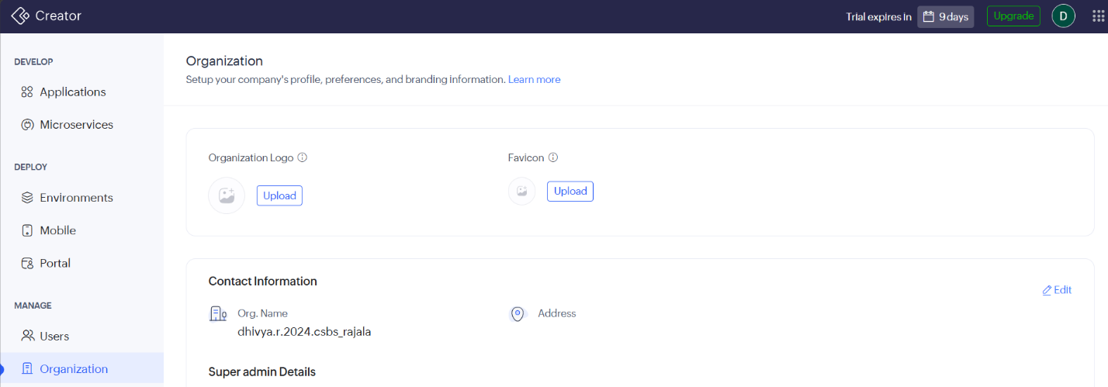

Purpose
The Organization module in Zoho Creator is used to configure and manage an organization's profile, branding, contact information, and system preferences. It serves as the central location for defining the organization's identity and default settings used across all applications.
Description
The Organization interface in Zoho Creator allows administrators to configure and manage the organization's profile, branding, and administrative settings from a centralized location. It enables users to upload the organization logo and favicon, maintain company contact information, configure the organization namespace, set the default time zone, and manage super administrator details. These settings help establish a consistent brand identity, ensure applications operate according to organizational and regional requirements, and provide a standardized environment for application development, deployment, and collaboration across the organization.

Feature Name: Governance
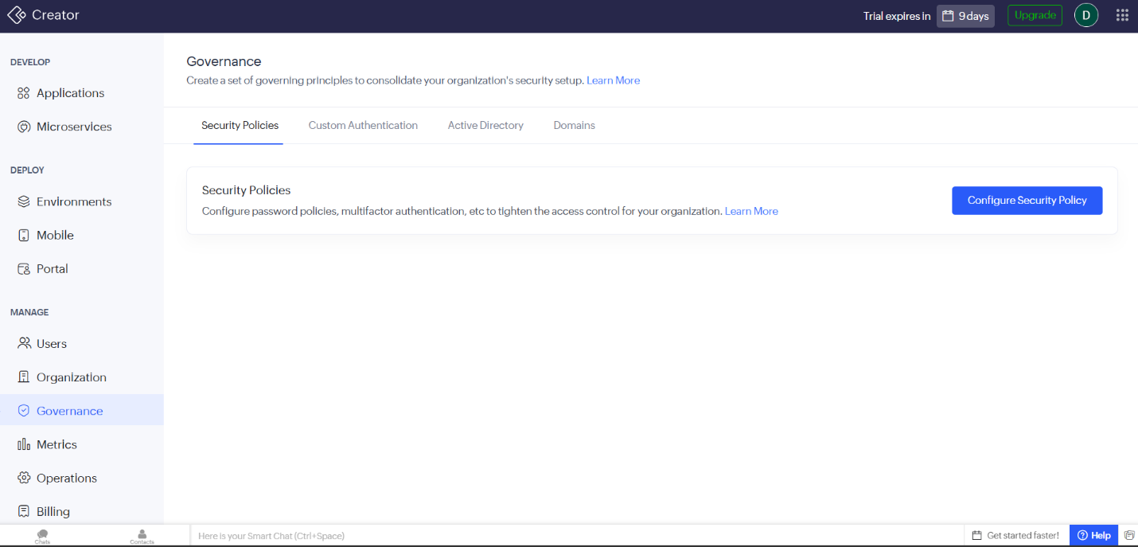

Purpose
The Governance module in Zoho Creator enables organizations to establish and enforce security policies, authentication methods, and access control mechanisms. It helps administrators maintain a secure application environment by defining organization-wide governance and security standards.
Description
The Governance interface in Zoho Creator provides a centralized platform for managing organizational security and access control by allowing administrators to configure security policies, authentication methods, Active Directory integration, and trusted domains. It enables organizations to enforce password policies, enable multi-factor authentication (MFA), integrate with enterprise identity management systems, and implement custom authentication to protect applications and sensitive business data. By centralizing security configuration and user authentication, the Governance interface strengthens organizational security, simplifies user management, supports compliance with security standards, and ensures that only authorized users can access business applications.

Feature Name: Metrics

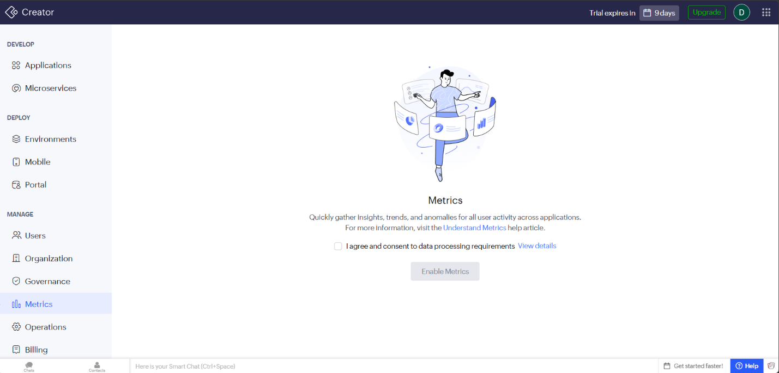

Purpose
The Metrics module in Zoho Creator enables organizations to monitor and analyse user activity across applications. It provides valuable insights into application usage, user behaviour, trends, and anomalies, helping administrators make informed decisions based on operational data.
Description
The Metrics interface in Zoho Creator enables administrators to collect, monitor, and analyze application usage data to gain insights into user activity and system performance. Once enabled with the required consent, it gathers information on user interactions, usage trends, and behavioral patterns, helping organizations evaluate application adoption, detect unusual activities, and identify opportunities for improvement. By providing centralized analytics and data-driven insights while adhering to privacy and compliance standards, the Metrics interface supports informed decision-making, enhances application performance, and improves overall operational efficiency.

Feature Name: Operations
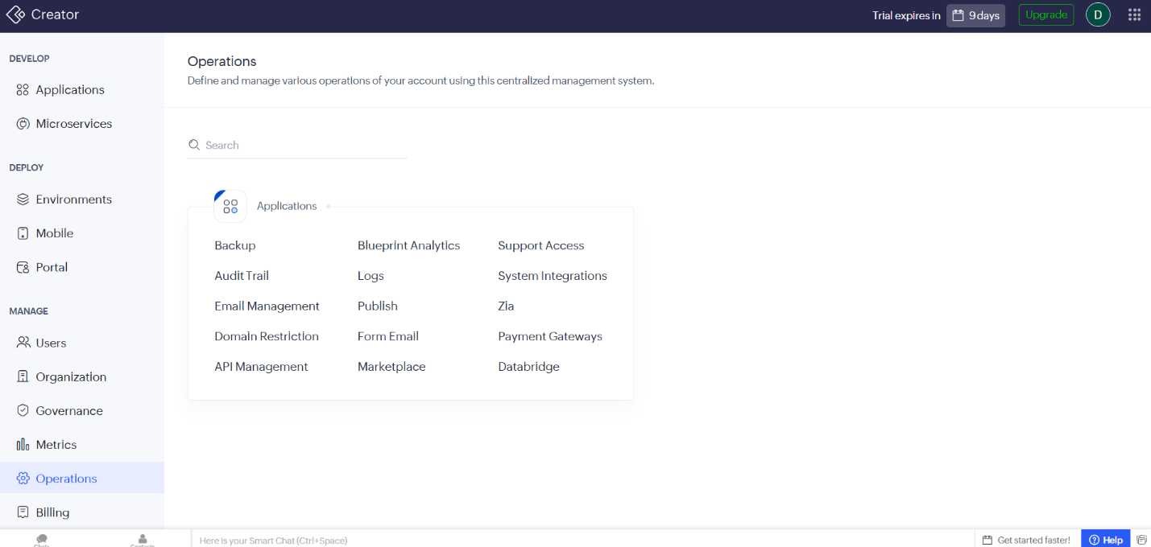

Purpose
The Operations module in Zoho Creator serves as a centralized management hub for configuring, monitoring, and maintaining various operational aspects of an organization's applications. It provides administrators with tools to manage backups, security, integrations, logs, publishing, and other essential system operations.
Description
The Operations interface in Zoho Creator provides a centralized platform for managing the administrative and operational aspects of business applications by bringing together modules such as Applications, Backup, Audit Trail, Email Management, API Management, Logs, Publish, Marketplace, Support Access, System Integrations, Zia, Payment Gateways, and Databridge. It enables administrators to perform system maintenance, configure integrations, manage communication settings, monitor application activities, and ensure secure and reliable operation from a single interface. By centralizing these functions, the Operations interface simplifies administration, enhances security through auditing and logging, supports seamless integration with external services, and improves overall system reliability, governance, and operational efficiency.

Feature Name: Billing
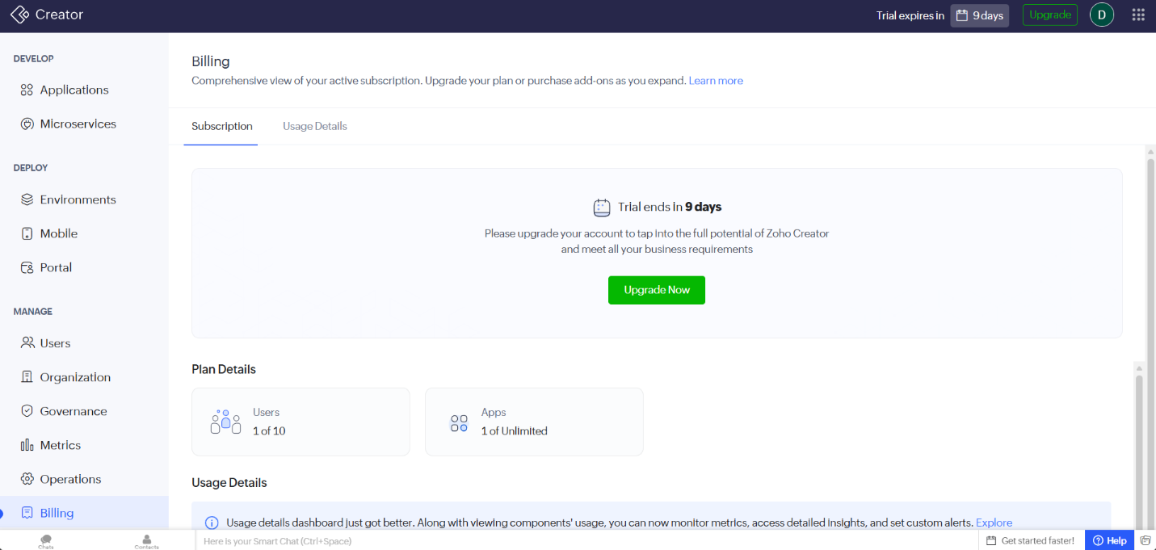

Purpose
The Billing module in Zoho Creator provides administrators with a comprehensive overview of the organization's subscription, resource usage, and licensing details. It enables users to monitor their current plan, track resource consumption, and upgrade their subscription as business requirements grow.

Description
The Billing interface in Zoho Creator provides a centralized platform for managing subscription plans, licensing information, and resource usage. It allows administrators to view subscription details, monitor trial status, track user and application limits, and analyze usage metrics through the Usage Details dashboard. The interface also supports upgrading subscription plans, purchasing additional add-ons, and configuring usage alerts to help organizations efficiently manage resources and avoid exceeding allocated limits. By offering clear visibility into subscription and consumption data, the Billing interface enables informed decision-making, optimizes resource utilization, and supports the growing needs of business applications.

